Anna University.

### A PROJECT STAGE I REPORT ON

**”DRUG TRACEABILITY USING IN BLOCKCHAIN”**

SUBMITTED TO THE UNIVERSITY OF ANNAMALAI,ANNA IN PARTIAL FULFILLMENT OF THE REQUIREMENTS FOR THE AWARD OF THE DEGREE

### BACHELOR OF ENGINEERING

**Computer Science & Engineering**

### BY

### Hemalatha - DE193A2B9DAAF11B0454FCDF0A56A53C Surya - 4445E51A78AD1E389F44600E57D7EFDD

### Sheik Dawood - EC2E02F6BF6BBED8AF3420B52208CB6A

### Hariharan - D71A163AF7B013F9D944C6E1F2835258

### UNDER THE GUIDANCE OF PROF. DIVYA

### DEPARTMENT OF COMPUTER SCIENCE & ENGINEERING SRI RAAJA RAAJAN COLLEGE OF ENGINEERING & TECHNOLOGY, AMARAVATHIPUDUR, KARAIKUDI.

### 2023-24

**CERTIFICATE**

This is to certify that Mane Kunal Dhananjay, Bendre Abhijit Tarachand, Take Swapnil Rajendra has completed the Project Report work under my guidance and su- pervision and that, I have verified the work for its originality in documentation, problem statement, and results presented in the project. Any reproduction of other necessary work is with the prior permission and has given due ownership and included in the refer- ences.

Place:

Date: (Prof. Divya )

**ACKNOWLEDGEMENT**

A successful work of Project is the result of inspiration, support, guidance, motiva- tion and cooperation of facilities during study. It gives me great pleasure to acknowledge my deep sense of gratitude to present my project titled: “DRUG TRACEABILITY IN HEALTHCARE SUPPLY CHAIN USING BLOCKCHAIN”. I would like to give sincere thanks to Prof. V. S. Dhongade Principal of Vishwabharti Academy college of Engineer- ing, Prof. S. G. Joshi Head of Department and Prof. R. N. Devray for there whole-hear ted support and affectionate encouragement without which my successful project would not have been possible. Last but not least I express my gratitude towards all staff mem- bers and non teaching faculties of Vishwabharati Academy’s College of Engineering and special thanks to my friends and family for their moral support and financial help.

Hemalatha

Surya

Sheik dawood

Hariharan

**ABSTRACT**

Drug traceability system is essentially important for public drug security and busi- ness of pharmaceutical companies, which aims to track or trace where the drug has been and where it has gone along the drug supply chain. Traditional centralized server-client technical solutions have been far from satisfying for their bad performances in data au- thenticity, privacy, system resilience and flexibility. We have proposed an entirely new blockchain system for drug traceability. This system is more secure and scalable than other alternatives on the market today. In addition, the proposed system is able to effectively prune its storage, resulting in a finally stable and usable blockchain storage solution. .

**Contents**

1. SYNOPSIS 2

1.1 Project Title . . . . . . . . . . . . . . . . . . . . . . . . . . . . . . . . . . 2

1.2 Technical Keywords . . . . . . . . . . . . . . . . . . . . . . . . . . . . . . 2

1.3 Problem definition . . . . . . . . . . . . . . . . . . . . . . . . . . . . . . 2

1. TECHNICAL KEYWORDS 3

2.1 Technical Keywords . . . . . . . . . . . . . . . . . . . . . . . . . . . . . . 3

2.2 Area of Project . . . . . . . . . . . . . . . . . . . . . . . . . . . . . . . . 3

1. INTRODUCTION 4

3.1 Introduction . . . . . . . . . . . . . . . . . . . . . . . . . . . . . . . . . . 4

3.2 Objectives . . . . . . . . . . . . . . . . . . . . . . . . . . . . . . . . . . . 5

3.3 Scope of Project . . . . . . . . . . . . . . . . . . . . . . . . . . . . . . . . 5

3.4 Motivation of Project . . . . . . . . . . . . . . . . . . . . . . . . . . . . . 5

3.5 Problem definition . . . . . . . . . . . . . . . . . . . . . . . . . . . . . . 6

1. LITERATURE SURVEY 7
2. SOFTWARE REQUIREMENT AND SPECIFICATION 10
   1. Introduction 10
      1. Project Scope 10
      2. User classes and characteristics 10
      3. Assumption and dependencies 11
   2. Functional Requirements 11
   3. External Interface Requirements 11
      1. User Interfaces 11
      2. Hardware Interfaces 11
      3. Software Interfaces 11
      4. Communication Interfaces 11
   4. Non-Functional Requirements 12

|  |  |  |  |
| --- | --- | --- | --- |
|  | 5.4.1 | Performance Requirement . . . . . . . . . . . . . . . . . . . . . . | 12 |
| 5.5 | System | Requirements . . . . . . . . . . . . . . . . . . . . . . . . . . . . . | 12 |
|  | 5.5.1 | Database Requirement . . . . . . . . . . . . . . . . . . . . . . . . | 12 |
|  | 5.5.2 | Software Requirement . . . . . . . . . . . . . . . . . . . . . . . . | 12 |
|  | 5.5.3 | Hardware Specifications . . . . . . . . . . . . . . . . . . . . . . . | 12 |

* 1. Analysis Model SDLC model should be applied 12
  2. System Implementation Plan 14

### ALGORITHM 15

* 1. MD5 (Message-Digest Algorithm) 15

### SYSYTEM DESIGN 16

* 1. System Architecture 16
  2. Mathematical Model 17
     1. Space Complexity: 17
     2. Time Complexity: 17
     3. Failures: 17
     4. Success: 18
  3. Data Flow Diagram 18
     1. DFD 18
  4. UML Diagram 19
     1. Use Case Diagram 19
     2. Activity Diagram 20

### PROJECT PLANNING 21

* 1. Project Estimate 21
     1. Cost Estimate 21
     2. Time Estimates 21
  2. Project Resources 22
  3. Project Task Set 22

### ADVANTAGES 23

* 1. Advantages 23

### APPLICATIONS 24

* 1. Applications 24

**ABREVATION**

|  |  |
| --- | --- |
| Acryonym | Defination |
| DFD | Data Flow Diagram. |
| BC | Block Chain. |
| SDLC | Software Development Life Cycle. |
| UML | Unified Modeling Language. |

**List of Figures**

* 1. SDLC Process 13
  2. Plan of Project Execution 14
  3. System Architecture 16
  4. DFD 18
  5. Use Case Diagram 19
  6. Activity Diagram 20

1

**Chapter 1 SYNOPSIS**

# Project Title

### Drug traceability in healthcare supply chain using blockchain

# Technical Keywords

Block chain, Traceability, Security, Data

# Problem definition

We Build and Implement Drug Traceabilty in healthcare supply chain using blockchain.

2

**Chapter 2**

**TECHNICAL KEYWORDS**

# Technical Keywords

Block chain, Traceability, Security, Data

# Area of Project

“Block Chain Technology”.

3

**Chapter 3 INTRODUCTION**

# Introduction

Drug traceability is essentially important for patients’ health, business operation, and government regulation. With a reliable drug traceability system, patients and stake- holders of the drug supply chain could conveniently know where the drug has gone or has been. Indeed, the drug traceability has also become more and more a compulsory mandate by governments around the world. For example, the U.S. Drug Supply Chain Security Act (DSCSA), which was signed into law on November 27, 2013, requires that an electronic, interoperable system should be built to identify and trace prescription drugs as they are distributed in the United States. In China, for approximately 8 years, stakehold- ers above had been required to upload the drug information of individual pharmaceutical products to the official designated IT system whenever there are drugs in or out of their warehouses.

Generally, a drug traceability system should be able to keep track or trace of the drug transaction flow through different stakeholders along the drug supply chain. It should provide reliable information about the flow for stakeholders and patients, especially that of drug production origin for anticounterfeit purpose. Or, at least it could be used to bind the responsibility of drug security to the relevant stakeholders for government regulation. Furthermore, the privacy of traceability data in the system is required to be protected as much as possible, especially that of statistical information (e.g. productivity, quantity of sale, etc.) of drugs that has been past the stakeholder. This paper presents Drug Traceability System, a fully scenario-oriented blockchain system for drug traceability and regulation. It reconstructs the whole service architecture, ensures the both authenticity and privacy of traceability data, and meanwhile achieves a finally stable blockchain stor- age with time going by. Algorithms reflecting the practical workflow of drug supply chain.

4

# Objectives

* + - We propose a blockchain-based solution for the pharmaceutical supply chain that provides security, traceability, immutability, and accessibility of data provenance for pharmaceutical drugs.
    - We design a smart contract capable of handling various transactions among phar- maceutical supply chain stakeholders.
    - We present, implement and test the smart contract that denes the working principles of our proposed solution.
    - We conduct security and cost analysis to evaluate the performance of the proposed blockchain-based solution.

# Scope of Project

A blockchain system for drug traceability and regulation is presented. As time goes on, it rebuilds the entire service architecture, ensuring the authenticity and privacy of traceability data, while at the same time, achieving a finally stable blockchain storage There have also been presented algorithms that mirror the practical workflow of the medication supply chain.

# Motivation of Project

* + - Healthcare supply chain is a complex network of several independent entities that include raw material suppliers, manufacturer, distributor, pharmacies, hospitals and patients.
    - Tracking supplies through this network is non-trivial due to several factors including lack of information, centralized control and competing behaviour among stakehold- ers.
    - Such complexity not only results in inefficiencies such as those highlighted through medical frauds but can also aggravate the challenge of mitigating against counterfeit drugs as these can easily permeate the healthcare supply chain.

# Problem definition

Drug fraud is a major problem faced by many pharmaceutical companies and, ac- cording to the Health Research Funding Organization, around 10% to 30% of drugs sold in the developing world are fake and, it’s the underground economy is valued at around

$200 billion annually. According to another report by the World Health Organization, around 16% of the counterfeit drugs contain the wrong ingredients. The main issue with such drugs is not that they’re just fake, but it’s mainly about the wrong ingredients that can put the patient’s life in danger.

To stop this fraud in india build and implement drug traceability in healthcare supply chain using block chain

**Chapter 4 LITERATURE SURVEY**

Literature survey is the most important step in any kind of research. Before start devel- oping we need to study the previous papers of our domain which we are working and on the basis of study we can predict or generate the drawback and start working with the reference of previous papers.

In this section, we briefly review the related work on Block chain technology.

R.Alvaro-Hermana, J. Fraile-Ardanuy, P. J. Zufiria, L. Knapen, and D. Janssens present the concept between two arrangements of electric vehicles, which fundamentally diminish the effect of the charging procedure on the power framework amid business hours. This trading approach is also economically beneficial for all the users involved in the trading process. An activity-based approach is used to predict the daily agenda and trips of a synthetic population for Flanders (Belgium).

Y. Xiao, D. Niyato, P. Wang, and Z. Han provide a study of the possible flow and functional factors that enable DET in communication networks. Various design issues on how to implement DET in practice are discussed. An ideal approach is created for delay-tolerant remote controlled correspondence organizes in which every remote powered device can masterminded its information transmission and energy exchanging activities as indicated by present and future vitality accessibility.

J. Kang, R. Yu, X. Huang, S. Maharjan, Y. Zhang, and E. Hossain presents a work to accomplishes request reaction by giving motivating forces to releasing PHEVs to adjust nearby power request out of their own self-interests. Be that as it may, since exchange se- curity and security insurance issues show genuine difficulties, they investigate a promising consortium block-chain innovation to enhance exchange security without dependence on

7

a confided in outsider. A restricted P2P Electricity Trading framework with Consortium block- chain (PETCON) strategy is proposed to represent detailed activities of limited P2P power exchanging.

N. Z. Aitzhan and D. Svetinovic presents a work that address the issue of providing transaction security in decentralized smart grid energy trading without confidence on trusted third parties. We have developed a proof-of-concept for decentralized energy trading system using blockchain technology, multi-signatures, and anonymous encrypted messaging flows, enabling peers to anonymously negotiate energy prices and securely per- form trading transactions.

M. Mihaylov, S. Jurado, N. Avellana, K. Van Moffaert, I. M. de Abril, and A. Now presents a work that shows decentralized computerized cash, called NRG-coin. Prosumers in the smart grid framework exchange privately made sustainable power source utilizing NRG-coins, the estimation of which is indented on an open cash trade advertise. Like Bit- coins, this money proposes various favorable circumstances over fiat cash, however not at all like Bit-coins it is made by infusing vitality into the matrix, as opposed to giving vi- tality on computational influence. Likewise, they make a novel exchanging worldview for purchasing and offering environmentally friendly power vitality in the smart grid network.

S. Barber et al presents a work that Bit-coin is isolated computerized cash which has pulled in a significant number of clients. They play out a top to bottom examination to comprehend what made Bit-coin so effective, while many years of research on crypto- graphic e-money have not prompt a vast scale appropriation. They ask additionally how Bit-coin could turn into a decent contender for seemingly perpetual stable money.

I. Alqassem et al presents a work that Bit-coin is constantly improved by an open source network, and different Bit-coin libraries, APIs, and elective usage are being created. All things considered, there is no up and coming convention contrast or design portrayal since the authority whitepaper was distributed. The work demonstrates an a la mode convention detail and design investigation of the Bit-coin framework. We play out this examination as the initial move towards determination of the cryptographic currency ref- erence design.

K. Croman et al presents a work that the expanding fame of block-chain-based digi- tal forms of money has made versatility an essential and earnest obligation. The work ponders how essential and incidental bottlenecks in Bit-coin restrict the ability of its

present distributed overlay system to help generously higher throughputs and lower la- tencies. These outcomes propose that re-parameterization of square size and interruption ought to be seen just as a first augmentation toward accomplishing people to come, high- stack block-chain conventions, and real advances will moreover require a fundamental reevaluating of specialized ways.

G. W. Peters and E. Panayipresents a work which give a diagram of the idea of block- chain innovation and its capacity to disturb the universe of managing an account through encouraging worldwide cash settlement, shrewd contracts, mechanized keeping money records and advanced resources. In such manner, they first give a concise outline of the center parts of this innovation, and in addition the second-age contract-based improve- ments.

L. Luu et al presents a work which gives another circulated understanding convention for authorization less block-chains called ELASTICO. ELASTICO scales exchange rates straightly with accessible estimation for mining: the more the calculation control in the system, the higher the quantity of exchange squares chosen per unit time. ELASTICO is productive in its system messages and permit complex foes of up to one-fourth of the aggregate computational power.

**Chapter 5**

**SOFTWARE REQUIREMENT AND SPECIFICATION**

# Introduction

Requirement analysis results in the specification of software’s operational character- istics indicates software’s interface with other system elements and establish constraints that software must meets. Requirement analysis allows the software engineer(sometime called Analyst or Modeler in this role) to elaborate on basis requirements during earlier requirement engineering task and build models that depict user scenarios, functional ac- tivities, problem classes and their relationship, system and class behavior and the flow of data as it is transformed. The requirements analysis task is a process of discovery, refinement, modeling and specification.

## Project Scope

A blockchain system for drug traceability and regulation is presented. As time goes on, it rebuilds the entire service architecture, ensuring the authenticity and privacy of traceability data, while at the same time, achieving a finally stable blockchain storage There have also been presented algorithms that mirror the practical workflow of the medication supply chain.

## User classes and characteristics

Our system have main three classes

1. Input data
2. processing: System can train the dataset for note character and number and when system get the input data that time they perform there relevant operation as preprocess-

10

ing, feature extraction, classification and segmentation.

1. Output: System have main class as output class where final result is show on screen as an output of recognize data.

## Assumption and dependencies

# Functional Requirements

The functional requirements for a system describe what system do.

1. The developed system should recognize tracaibility.
2. System shall show the error message to the user when given input is not in the required format.
3. System must provide the quality of service to user.

# External Interface Requirements

## User Interfaces

The system specifies the user interfaces are as follows:

1. Open application.
2. Login. iii) Supply chain

## Hardware Interfaces

The entire system interface with java and library.

## Software Interfaces

The system works on database so system fetch the data.

## Communication Interfaces

The system should also use standard protocols for image processing so we are uses various library for our project.

# Non-Functional Requirements

Non-functional requirements are not directly related to the functional behavior of the system.

## Performance Requirement

1. System must be user friendly, simple and interactive.
2. The user interface is designed in such way that novice users with little knowledge of library, should be able to access this application.
3. Users are required to have some knowledge regarding library module.
   1. **System Requirements**
      1. **Database Requirement**

MySQL Database

* + 1. **Software Requirement**

1. Operating System: Windows 8 or higher.
2. Platform: Eclipse.
3. Technologies used: Java.
   * 1. **Hardware Specifications**
4. Processor: i3 or higher.
5. Processor speed: 2.0GHz.
6. RAM: 4 GB.
7. Disk Space: 20 GB or higher.
   1. **Analysis Model SDLC model should be applied**

SDLC Processes regarding to the Project:-

1. System Design:- The requirement specifications from first phase are studied in this phase and system design is prepared. System Design helps in specifying hardware and system requirements and also helps in defining overall system architecture. The software code to be written in the next stage is created now.
2. Implementation:- With inputs from system design, the system is first developed in small programs called units, which are integrated in the next phase. Each unit is developed and tested for its functionality which is referred to as Unit Testing.
3. Integration and Testing:- All the units developed in the implementation phase are integrated into a system after testing of each unit. The software designed, needs to go through constant software testing to find out if there are any flaw or errors. Testing is done so that the client does not face any problem during the installation of the software.
4. Deployment of System:- Once the functional and non-functional testing is done, the product is deployed in the customer environment or released into the market.
5. Maintenance:- This step occurs after installation, and involves making modifications to the system or an individual component to alter attributes or improve performance. These modifications arise either due to change requests initiated by the customer, or defects uncovered during live use of the system. Client is provided with regular maintenance and support for the developed software. All these phases are cascaded to each other in which progress is seen as flowing steadily downwards (like a waterfall) through the phases. The next phase is started only after the defined set of goals are achieved for previous phase and it is signed off, so the name Waterfall Model.

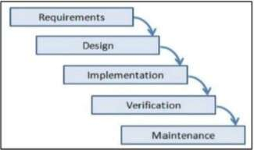

Figure 5.1: SDLC Process

* 1. **System Implementation Plan**

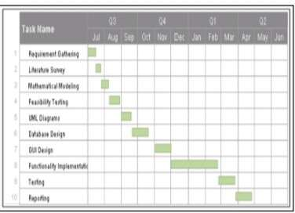

Figure 5.2: Plan of Project Execution

**Chapter 6 ALGORITHM**

**6.1 MD5 (Message-Digest Algorithm)**

The MD5 message-digest algorithm is a widely used cryptographic hash function pro- ducing a 128-bit (16-byte) hash value, typically expressed in text format as a 32 digit hexadecimal number. MD5 has been utilized in a wide variety of cryptographic applica- tions, and is also commonly used to verify data integrity.

Steps:

1. A message digest algorithm is a hash function that takes a bit sequence of any length and produces a bit sequence of a fixed small length.
2. The output of a message digest is considered as a digital signature of the input data.
3. MD5 is a message digest algorithm producing 128 bits of data.
4. It uses constants derived to trigonometric Sine function.
5. It loops through the original message in blocks of 512 bits, with 4 rounds of operations for each block, and 16 operations in each round.
6. Most modern programming languages provides MD5 algorithm as built-in functions

15

**Chapter 7 SYSYTEM DESIGN**

* 1. **System Architecture**

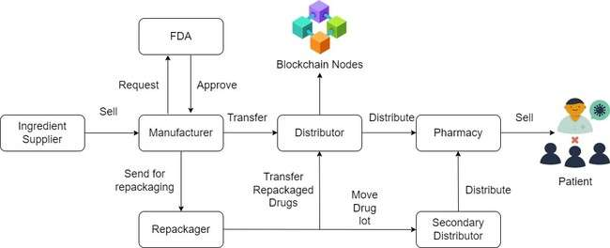

Figure 7.1: System Architecture

Our method identifies and involves significant stakeholders in the medication sup- ply chain, such as the FDA, suppliers, manufacturers, distributors, pharmacies, and pa- tients, whereas the FDA, suppliers, manufacturers, and wholesalers are the only ones involved.We make a concerted effort to identify and disentangle linkages between stake- holders, on-chain resources, smart contracts, and decentralised storage systems, which is currently lacking.We use smart contracts technology to achieve real-time, seamless traceability with push alerts, reducing the need for human intervention and, as a result, unnecessary delays.Each drug Lot is given its own smart contract, which generates an event whenever there is a change in ownership and sends a list of events to the app user.

16

* 1. **Mathematical Model**

Let us consider S as a system S=

INPUT:

Identify the inputs

F= f1, f2, f3 , FN— F as set of functions to execute commands.

I= i1, i2, i3—I sets of inputs to the function set

O= o1, o2, o3.—O Set of outputs from the function sets, S= I, F, O

I = Input

O = Output

F = Functions implemented to get the output

* + 1. **Space Complexity:**

The space complexity depends on Presentation and visualization of discovered patterns. More the storage of data more is the space complexity.

* + 1. **Time Complexity:**

Check No. of patterns available in the datasets= n If (n(1)) then retrieving of information can be time consuming. So the time complexity of this algorithm is O (nˆn). = Failures and Success conditions.

* + 1. **Failures:**

1. Huge database can lead to more time consumption to get the information.
2. Hardware failure.
3. Software failure.
   * 1. **Success:**
4. Search the required information from available in Datasets.
5. User gets result very fast according to their needs.
   1. **Data Flow Diagram**

A data flow diagram (DFD) is a graphical representation of the ”flow” of data through an information system, modeling its process aspects. A DFD is often used as a preliminary step to create an overview of the system, which can later be elaborated. DFDs can also be used for the visualization of data processing.

* + 1. **DFD**

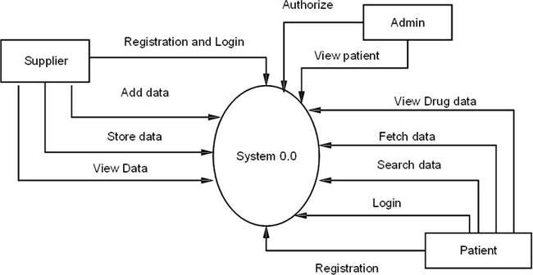

Figure 7.2: DFD

* 1. **UML Diagram**
     1. **Use Case Diagram**

A Use Case Diagram consists of set of elements and the relationships between them. It depicts all the scenarios, regarding how our application interacts with users and other external systems to achieve the goals of application. The main components of a use case diagram include actors, use cases and their relationships. The use case is an external view of the system that represents some actions that the user performs to get a job done. Actors are the users who interact with the application.

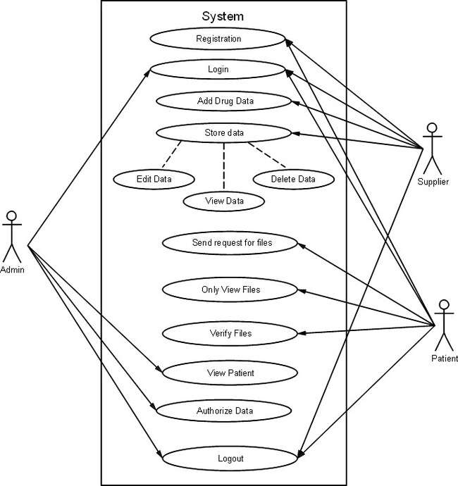

Figure 7.3: Use Case Diagram

* + 1. **Activity Diagram**

Activity diagram is basically a flowchart to represent the flow from one activity to another activity. The activity can be described as an operation of the system. The main element of an activity diagram is the activity itself. An activity is a function performed by the system. After identifying the activities, we need to understand how they are associated with constraints and conditions.

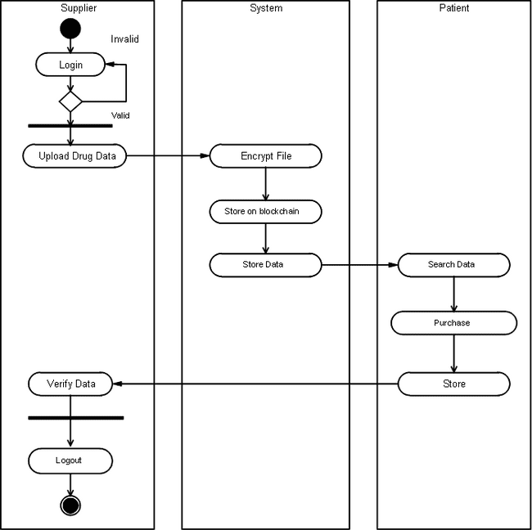

Figure 7.4: Activity Diagram

**Chapter 8**

**PROJECT PLANNING**

* 1. **Project Estimate**

Use Waterfall model and associated streams derived from assignments 1, 2, 3, 4 and 5 (Annex A and B) for estimation.

* + 1. **Cost Estimate**

The cost excluding the working machines i.e. The laptops and the electricity re- quirement are calculated. As we are going to use majority of freeware, the software cost is nil. The remaining cost is

Manpower cost = 4 persons x 10 hrs./wk. = 40 hrs. Cost calculated for work hrs. = Rs 300/wk.

In this way we estimate to work for 30 weeks. Hence cost = 40x 300 = Rs 12000.

The overall developing and testing would cost approximately Rs 2000. Further cost would include the documentation and deployment costs. The maintaining cost at end user after deployment is not considered currently. Hence after all estimations and keeping a considerable cost buffer we estimate the project cost to go at about. Rs 14000.

* + 1. **Time Estimates**

The project should be deployed in the given timeframe else there is no point in developing the project if it elapses the marketability time. A timeframe of 6 months is being decided and considering the functionality to be developed and the available manpower, equipment and software, the timeline is perfectly achievable.

21

* 1. **Project Resources**

Project resources [People, Hardware, Software, Tools and other resources] based on task offloading, Cloud computing, and android programming to be referred.

* 1. **Project Task Set**

Major Tasks in the Project stages are:

1. Task 1: To develop the problem under consideration and justify feasibility using con- cepts of knowledge canvas and IDEA matrix.
2. Task 2: Project problem statement feasibility assessment using NP-Hard, NP-Complete or satiability issues using modern algebra and/or relevant mathematical models.
3. Task 3: Use of divide and conquer strategies to exploit distributed/parallel/concurrent processing of the above to identify objects, morphisms, overloading in functions (if any), and functional relations and any other dependencies (as per requirements).
4. Task 4: Use of above to draw functional dependency graphs and relevant Software modelling methods, techniques including UML diagrams or other necessities using appro- priate tools.
5. Task 5: Testing of project problem statement using generated test data (using math- ematical models, GUI, Function testing principles, if any) selection and appropriate use of testing tools, testing of UML diagram’s reliability.

**Chapter 9 ADVANTAGES**

**9.1 Advantages**

1. We propose a blockchain-based solution for the pharmaceutical supply chain that pro- vides security, traceability, immutability, and accessibility of data provenance for phar- maceutical drugs.
2. We design a smart contract capable of handling various transactions among pharma- ceutical supply chain stakeholders.
3. We present, implement and test the smart contract that denes the working principles of our proposed solution.
4. We conduct security and cost analysis to evaluate the performance of the proposed blockchain-based solution.

23

**Chapter 10 APPLICATIONS**

**10.1 Applications**

1. Medical Application
2. Healthcare Application

24

**CONCLUSION**

we have investigated the challenge of drug traceability within pharmaceutical sup- ply chains highlighting its significance especially to protect against counterfeit drugs. We have developed and evaluated a blockchain-based solution for the pharmaceutical supply chain to track and trace drugs in a decentralized manner. Specifically, our proposed so- lution leverages cryptographic fundamentals underlying blockchain technology to achieve tamper-proof logs of events within the supply chain and utilizes smart contracts within Ethereum blockchain to achieve automated recording of events that are accessible to all participating stakeholders.

**References**

* 1. F. Jamil, L. Hang, K. Kim, and D. Kim, “A novel medical blockchain model for drug supply chain integrity management in a smart hospital,” Electronics, vol. 8, p. 505, Apr. 2019, doi: 10.3390/electronics8050505.
  2. Y. Huang, J.Wu, and C. Long, “Drugledger:Apractical blockchain system for drug traceability and regulation,” in Proc. IEEE Conf. Internet Things, Jul./Aug. 2018, pp. 1137 1144.
  3. S. Delgado-Segura, C. P´erez-Sol`a, G. Navarro-Arribas, and J. HerreraJoancomart´ı, “Analysis of the bitcoin UTXO set,” in Financial Cryptography and Data Security (Lecture Notes in Computer Science), vol. 10958, A. Zohar, Ed. Berlin, Germany: Springer, 2019, pp. 78 91.
  4. K. M. Khan, J. Arshad, and M. M. Khan, “Investigating performance constraints for blockchain based secure e-voting system,” Future Gener. Comput. Syst., vol. 105, pp. 13 26, Apr. 2020.
  5. D. Vujicic, D. Jagodic, and S. Randic, “Blockchain technology, bitcoin, and Ethereum: A brief overview,” in Proc. 17th Int. Symp. Infoteh- Jahorina (INFOTEH), East Sarajevo, Srpska, Mar. 2018, pp. 1 6, doi: 10.1109/INFOTEH.2018.8345547.
  6. . Jiang, J. Cao, H. Wu, Y. Yang, M. Ma, and J. He, “BlocHIE: A blockchain- based platform for healthcare information exchange,” in Proc. IEEE Int. Conf. Smart Comput. (SMARTCOMP), Jun. 2018, pp. 49–56.
  7. W. J. Gordon and C. Catalini, “Blockchain technology for healthcare: Facilitating the transition to patient-driven interoperability,” Comput. Struct. Biotechnol J., vol. 16, pp. 224–230, 2018.
  8. Anjia yang, Wei Lu, Yue Zhang, Lin Hou” CrowdBC: A Blockchain-based Decen- tralized a Framework for Crowdsourcing” IEEE , vol. 7, May.2018.
  9. S. Wang, Y. Zhang, and Y. Zhang, “A blockchain-based framework for data sharing with fine-grained access control in decentralized storage systems,” IEEE Access, vol. 6, pp. 38437–38450, Jun.2018.
  10. M. Steichen, R. Norvill, B. F. Pontiveros, and W. Shbair,“Blockchainbased, de- centralized access control for IPFS,” in Proc. IEEE Blockchain, Jul. 2018, pp. 1499–1506.